**TUGAS WORKSHOP APLIKASI MOBILE**



**Oleh :**

**Aditia Afif Arfiansyah**

**E41161395**

**TIF C**

**KEMENTRIAN RISET, TEKNOLOGI, DAN PENDIDIKAN TINGGI**

**PROGRAM STUDI D-IV TEKNIK INFORMATIKA**

**JURUSAN TEKNOLOGI INFORMASI**

**POLITEKNIK NEGERI JEMBER**

**TAHUN 2018**

1. Membuat Splash Screen.

* Pertama saya membuat splash sreen, disini kita tempatkan dulu foto/gambar yang akan dijadikan splash sreen pada res->drawable agar dapat kita gunakan. dan ini design dari splash sreen tersebut:

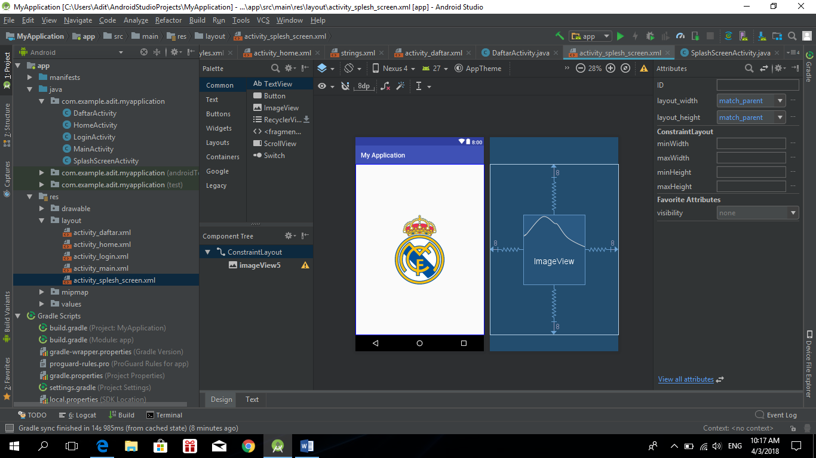

* Xml activity_splash_screen:

<?xml version="1.0" encoding="utf-8"?>  
<android.support.constraint.ConstraintLayout xmlns:android="http://schemas.android.com/apk/res/android"  
 xmlns:app="http://schemas.android.com/apk/res-auto"  
 xmlns:tools="http://schemas.android.com/tools"  
 android:layout_width="match_parent"  
 android:layout_height="match_parent"  
 tools:context=".SplashScreenActivity">  
  
 <ImageView  
 android:id="@+id/imageView5"  
 android:layout_width="185dp"  
 android:layout_height="209dp"  
 android:layout_marginBottom="8dp"  
 android:layout_marginEnd="8dp"  
 android:layout_marginLeft="8dp"  
 android:layout_marginRight="8dp"  
 android:layout_marginStart="8dp"  
 android:layout_marginTop="8dp"  
 app:layout_constraintBottom_toBottomOf="parent"  
 app:layout_constraintEnd_toEndOf="parent"  
 app:layout_constraintStart_toStartOf="parent"  
 app:layout_constraintTop_toTopOf="parent"  
 app:srcCompat="@drawable/madrid" />

* Coding SplashSreenActivity:

package com.example.adit.myapplication;  
  
import android.content.Intent;  
import android.os.Handler;  
import android.support.v7.app.AppCompatActivity;  
import android.os.Bundle;  
  
public class SplashScreenActivity extends AppCompatActivity {  
  
 @Override  
 protected void onCreate(Bundle savedInstanceState) {  
 super.onCreate(savedInstanceState);  
 setContentView(R.layout.*activity_splesh_screen*);  
  
 Handler handler = new Handler();  
 handler.postDelayed(new Runnable() {  
 @Override  
 public void run() {  
 Intent intent = new Intent(SplashScreenActivity.this, MainActivity.class);  
 startActivity(intent);  
 finish();  
 }  
 },3000L);  
 }  
}

* Atur manifest agar activity splash sreen muncul pertama kali, berikut xmlnya:

<?xml version="1.0" encoding="utf-8"?>  
<manifest xmlns:android="http://schemas.android.com/apk/res/android"  
 package="com.example.adit.myapplication">  
  
 <application  
 android:allowBackup="true"  
 android:icon="@mipmap/ic_launcher"  
 android:label="@string/app_name"  
 android:roundIcon="@mipmap/ic_launcher_round"  
 android:supportsRtl="true"  
 android:theme="@style/AppTheme">  
 <activity android:name=".MainActivity">  
  
 </activity>  
 <activity android:name=".LoginActivity" />  
 <activity android:name=".HomeActivity" />  
 <activity android:name=".DaftarActivity" />  
 <activity android:name=".SplashScreenActivity">  
 <intent-filter>  
 <action android:name="android.intent.action.MAIN" />  
  
 <category android:name="android.intent.category.LAUNCHER" />  
 </intent-filter>  
 </activity>  
 </application>  
  
</manifest>

* Output tampilan splash sreen:



1. Membuat MainActivity

* Design mainActivity:

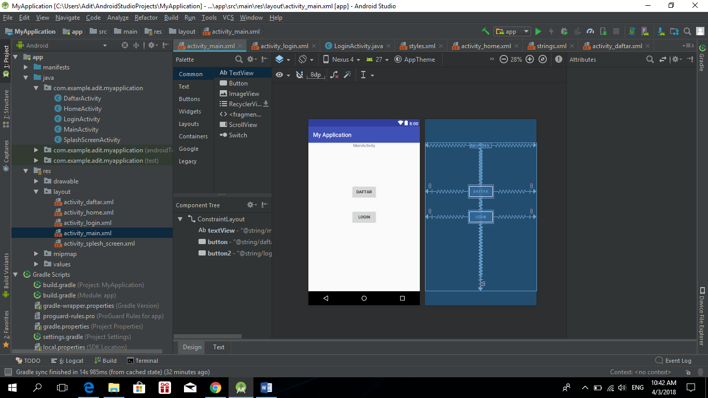

* Xml activity_main:

<?xml version="1.0" encoding="utf-8"?>  
<android.support.constraint.ConstraintLayout xmlns:android="http://schemas.android.com/apk/res/android"  
 xmlns:app="http://schemas.android.com/apk/res-auto"  
 xmlns:tools="http://schemas.android.com/tools"  
 android:layout_width="match_parent"  
 android:layout_height="match_parent"  
 tools:context=".MainActivity">  
  
 <TextView  
 android:id="@+id/textView"  
 android:layout_width="wrap_content"  
 android:layout_height="wrap_content"  
 android:text="@string/mainactivity"  
 app:layout_constraintBottom_toBottomOf="parent"  
 app:layout_constraintLeft_toLeftOf="parent"  
 app:layout_constraintRight_toRightOf="parent"  
 app:layout_constraintTop_toTopOf="parent"  
 app:layout_constraintVertical_bias="0.0" />  
  
 <Button  
 android:id="@+id/button"  
 android:layout_width="wrap_content"  
 android:layout_height="wrap_content"  
 android:layout_marginBottom="8dp"  
 android:layout_marginEnd="8dp"  
 android:layout_marginLeft="8dp"  
 android:layout_marginRight="8dp"  
 android:layout_marginStart="8dp"  
 android:layout_marginTop="8dp"  
 android:text="@string/daftar"  
 app:layout_constraintBottom_toBottomOf="parent"  
 app:layout_constraintEnd_toEndOf="parent"  
 app:layout_constraintStart_toStartOf="parent"  
 app:layout_constraintTop_toTopOf="@+id/textView"  
 app:layout_constraintVertical_bias="0.306" />  
  
 <Button  
 android:id="@+id/button2"  
 android:layout_width="wrap_content"  
 android:layout_height="wrap_content"  
 android:layout_marginBottom="8dp"  
 android:layout_marginEnd="8dp"  
 android:layout_marginLeft="8dp"  
 android:layout_marginRight="8dp"  
 android:layout_marginStart="8dp"  
 android:layout_marginTop="8dp"  
 android:text="@string/login"  
 app:layout_constraintBottom_toBottomOf="parent"  
 app:layout_constraintEnd_toEndOf="parent"  
 app:layout_constraintStart_toStartOf="parent"  
 app:layout_constraintTop_toTopOf="@+id/textView" />  
  
</android.support.constraint.ConstraintLayout>

* Coding MainActivity:

package com.example.adit.myapplication;  
  
import android.content.Intent;  
import android.support.v7.app.AppCompatActivity;  
import android.os.Bundle;  
import android.view.View;  
import android.widget.Button;  
  
public class MainActivity extends AppCompatActivity {  
  
 @Override  
 protected void onCreate(Bundle savedInstanceState) {  
 super.onCreate(savedInstanceState);  
 setContentView(R.layout.*activity_main*);  
 Button button = (Button) findViewById(R.id.*button*);  
  
 button.setOnClickListener(new View.OnClickListener() {  
 @Override  
 public void onClick(View view) {  
  
 Intent il = new Intent (getApplicationContext(),DaftarActivity.class);  
 startActivity(il);  
 }  
 });  
  
 Button button2 = (Button) findViewById(R.id.*button2*);  
  
 button2.setOnClickListener(new View.OnClickListener() {  
 @Override  
 public void onClick(View view) {  
  
 Intent il = new Intent (getApplicationContext(),LoginActivity.class);  
 startActivity(il);  
 }  
 });  
 }

* Output MainActivity:

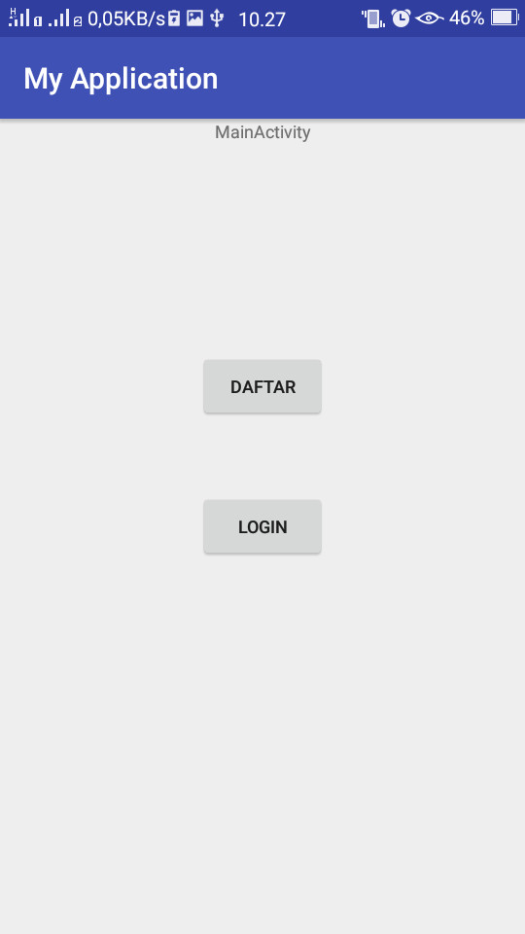

1. Membuat Activity Daftar

* Design activity daftar:

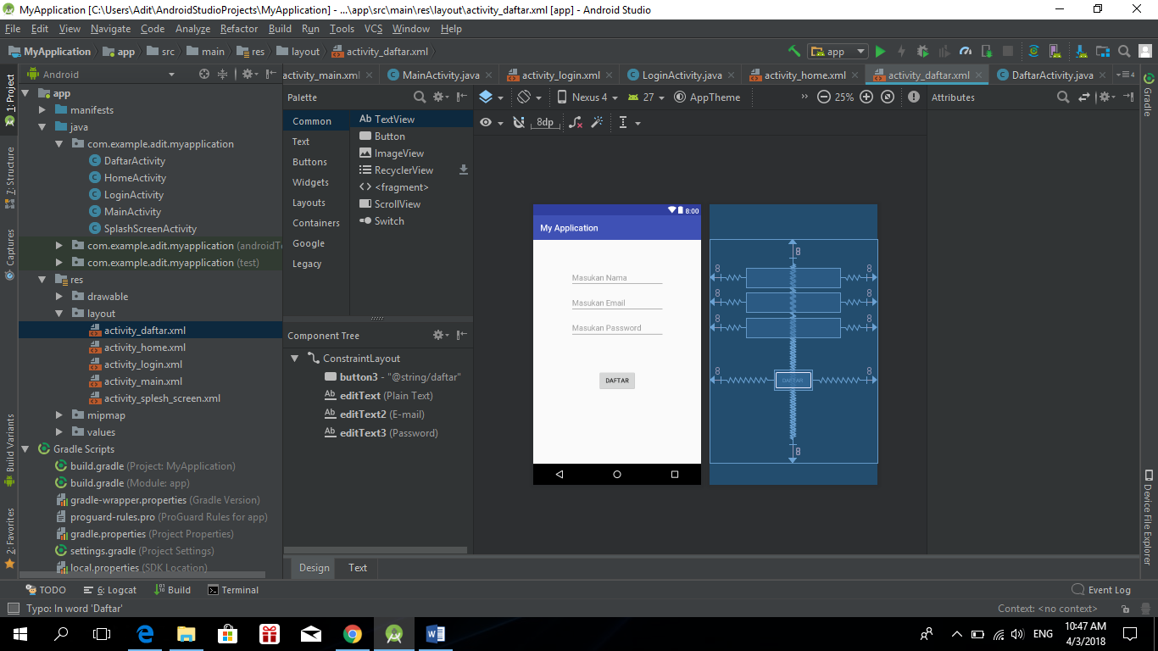

* Xml activity_daftar:

<?xml version="1.0" encoding="utf-8"?>  
<android.support.constraint.ConstraintLayout xmlns:android="http://schemas.android.com/apk/res/android"  
 xmlns:app="http://schemas.android.com/apk/res-auto"  
 xmlns:tools="http://schemas.android.com/tools"  
 android:layout_width="match_parent"  
 android:layout_height="match_parent"  
 tools:context=".DaftarActivity">  
  
 <Button  
 android:id="@+id/button3"  
 android:layout_width="wrap_content"  
 android:layout_height="wrap_content"  
 android:layout_marginBottom="8dp"  
 android:layout_marginEnd="8dp"  
 android:layout_marginLeft="8dp"  
 android:layout_marginRight="8dp"  
 android:layout_marginStart="8dp"  
 android:layout_marginTop="8dp"  
 android:text="@string/daftar"  
 app:layout_constraintBottom_toBottomOf="parent"  
 app:layout_constraintEnd_toEndOf="parent"  
 app:layout_constraintStart_toStartOf="parent"  
 app:layout_constraintTop_toTopOf="parent"  
 app:layout_constraintVertical_bias="0.646" />  
  
 <EditText  
 android:id="@+id/editText"  
 android:layout_width="wrap_content"  
 android:layout_height="wrap_content"  
 android:layout_marginBottom="8dp"  
 android:layout_marginEnd="8dp"  
 android:layout_marginLeft="8dp"  
 android:layout_marginRight="8dp"  
 android:layout_marginStart="8dp"  
 android:layout_marginTop="8dp"  
 android:ems="10"  
 android:hint="@string/masukan_nama"  
 android:inputType="textPersonName"  
 android:singleLine="false"  
 app:layout_constraintBottom_toBottomOf="parent"  
 app:layout_constraintEnd_toEndOf="parent"  
 app:layout_constraintHorizontal_bias="0.503"  
 app:layout_constraintStart_toStartOf="parent"  
 app:layout_constraintTop_toTopOf="parent"  
 app:layout_constraintVertical_bias="0.124" />  
  
 <EditText  
 android:id="@+id/editText2"  
 android:layout_width="wrap_content"  
 android:layout_height="wrap_content"  
 android:layout_marginBottom="8dp"  
 android:layout_marginEnd="8dp"  
 android:layout_marginLeft="8dp"  
 android:layout_marginRight="8dp"  
 android:layout_marginStart="8dp"  
 android:layout_marginTop="8dp"  
 android:ems="10"  
 android:hint="@string/masukan_email"  
 android:inputType="textEmailAddress"  
 app:layout_constraintBottom_toBottomOf="parent"  
 app:layout_constraintEnd_toEndOf="parent"  
 app:layout_constraintHorizontal_bias="0.503"  
 app:layout_constraintStart_toStartOf="parent"  
 app:layout_constraintTop_toTopOf="parent"  
 app:layout_constraintVertical_bias="0.251" />  
  
 <EditText  
 android:id="@+id/editText3"  
 android:layout_width="wrap_content"  
 android:layout_height="wrap_content"  
 android:layout_marginBottom="8dp"  
 android:layout_marginEnd="8dp"  
 android:layout_marginLeft="8dp"  
 android:layout_marginRight="8dp"  
 android:layout_marginStart="8dp"  
 android:layout_marginTop="8dp"  
 android:ems="10"  
 android:hint="@string/masukan_password"  
 android:inputType="textPassword"  
 app:layout_constraintBottom_toBottomOf="parent"  
 app:layout_constraintEnd_toEndOf="parent"  
 app:layout_constraintHorizontal_bias="0.503"  
 app:layout_constraintStart_toStartOf="parent"  
 app:layout_constraintTop_toTopOf="parent"  
 app:layout_constraintVertical_bias="0.378" />  
</android.support.constraint.ConstraintLayout>

* Coding DaftarActivity:

package com.example.adit.myapplication;  
  
import android.content.Intent;  
import android.support.v7.app.AppCompatActivity;  
import android.os.Bundle;  
import android.view.View;  
import android.widget.Button;  
  
public class DaftarActivity extends AppCompatActivity {  
  
 @Override  
 protected void onCreate(Bundle savedInstanceState) {  
 super.onCreate(savedInstanceState);  
 setContentView(R.layout.*activity_daftar*);  
  
 Button button3 = (Button) findViewById(R.id.*button3*);  
  
 button3.setOnClickListener(new View.OnClickListener() {  
 @Override  
 public void onClick(View view) {  
  
 Intent il = new Intent (getApplicationContext(),MainActivity.class);  
 startActivity(il);  
 }  
 });  
 }  
}

* Output Activity Daftar:

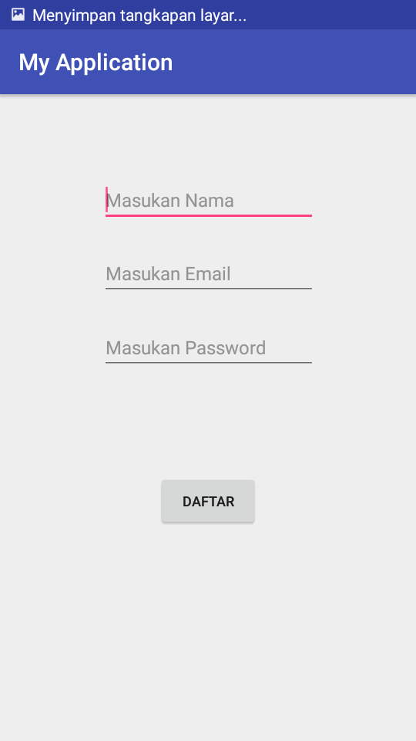

1. Membuat Activity Login

* Design activity login:

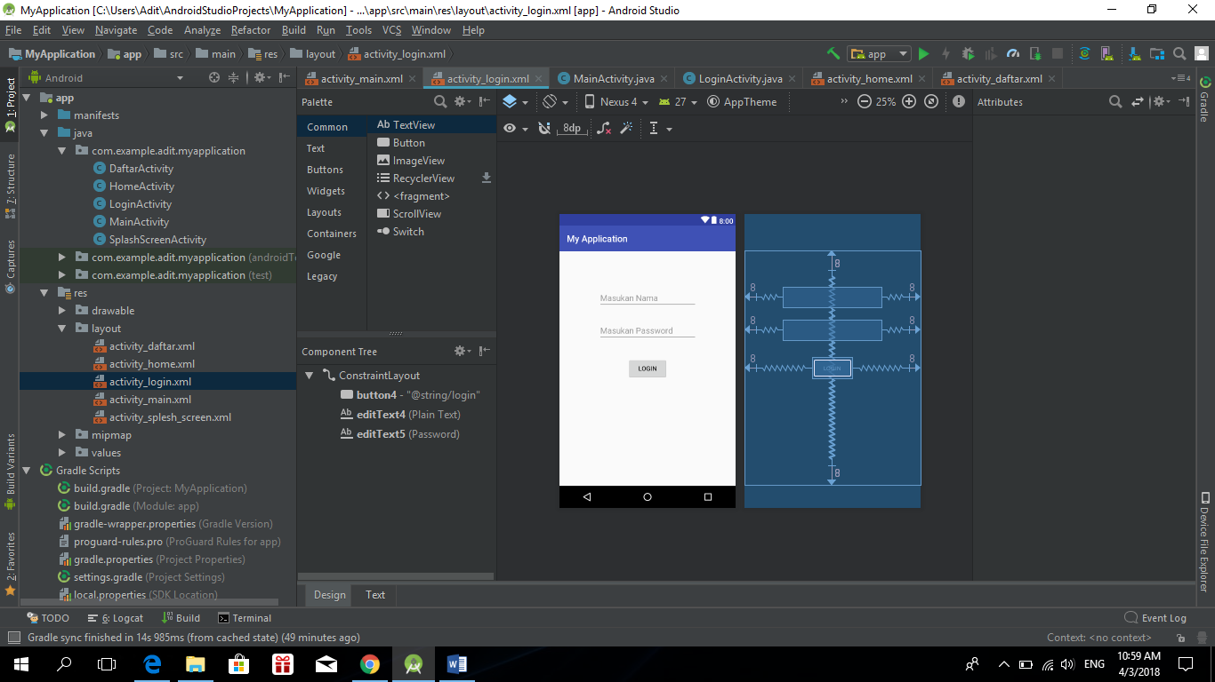

* Xml activity_login:

<?xml version="1.0" encoding="utf-8"?>  
<android.support.constraint.ConstraintLayout xmlns:android="http://schemas.android.com/apk/res/android"  
 xmlns:app="http://schemas.android.com/apk/res-auto"  
 xmlns:tools="http://schemas.android.com/tools"  
 android:layout_width="match_parent"  
 android:layout_height="match_parent"  
 tools:context=".LoginActivity">  
  
 <Button  
 android:id="@+id/button4"  
 android:layout_width="wrap_content"  
 android:layout_height="wrap_content"  
 android:layout_marginBottom="8dp"  
 android:layout_marginEnd="8dp"  
 android:layout_marginLeft="8dp"  
 android:layout_marginRight="8dp"  
 android:layout_marginStart="8dp"  
 android:layout_marginTop="8dp"  
 android:text="@string/login"  
 app:layout_constraintBottom_toBottomOf="parent"  
 app:layout_constraintEnd_toEndOf="parent"  
 app:layout_constraintStart_toStartOf="parent"  
 app:layout_constraintTop_toTopOf="parent" />  
  
 <EditText  
 android:id="@+id/editText4"  
 android:layout_width="wrap_content"  
 android:layout_height="wrap_content"  
 android:layout_marginBottom="8dp"  
 android:layout_marginEnd="8dp"  
 android:layout_marginLeft="8dp"  
 android:layout_marginRight="8dp"  
 android:layout_marginStart="8dp"  
 android:layout_marginTop="8dp"  
 android:ems="10"  
 android:hint="@string/masukan_nama"  
 android:inputType="textPersonName"  
 app:layout_constraintBottom_toBottomOf="parent"  
 app:layout_constraintEnd_toEndOf="parent"  
 app:layout_constraintHorizontal_bias="0.503"  
 app:layout_constraintStart_toStartOf="parent"  
 app:layout_constraintTop_toTopOf="parent"  
 app:layout_constraintVertical_bias="0.158" />  
  
 <EditText  
 android:id="@+id/editText5"  
 android:layout_width="wrap_content"  
 android:layout_height="wrap_content"  
 android:layout_marginBottom="8dp"  
 android:layout_marginEnd="8dp"  
 android:layout_marginLeft="8dp"  
 android:layout_marginRight="8dp"  
 android:layout_marginStart="8dp"  
 android:layout_marginTop="8dp"  
 android:ems="10"  
 android:hint="@string/masukan_password"  
 android:inputType="textPassword"  
 app:layout_constraintBottom_toBottomOf="parent"  
 app:layout_constraintEnd_toEndOf="parent"  
 app:layout_constraintHorizontal_bias="0.503"  
 app:layout_constraintStart_toStartOf="parent"  
 app:layout_constraintTop_toTopOf="parent"  
 app:layout_constraintVertical_bias="0.316" />

* Coding LoginActivity:

package com.example.adit.myapplication;  
  
import android.content.Context;  
import android.content.Intent;  
import android.content.SharedPreferences;  
import android.support.v7.app.AppCompatActivity;  
import android.os.Bundle;  
import android.view.View;  
import android.widget.Button;  
import android.widget.EditText;  
  
public class LoginActivity extends AppCompatActivity {  
 public SharedPreferences coba;  
  
  
 @Override  
 protected void onCreate(Bundle savedInstanceState) {  
 super.onCreate(savedInstanceState);  
 setContentView(R.layout.*activity_login*);  
  
 final EditText editText4 = (EditText) findViewById(R.id.*editText4*);  
 final EditText editText5 = (EditText) findViewById(R.id.*editText5*);  
  
 Button button4 = (Button) findViewById(R.id.*button4*);  
  
 coba = getSharedPreferences("data", Context.*MODE_PRIVATE*);  
 editText4.setText(coba.getString("username", ""));  
 editText5.setText(coba.getString("password", ""));  
  
  
 button4.setOnClickListener(new View.OnClickListener() {  
 @Override  
 public void onClick(View view) {  
  
 SharedPreferences.Editor edit =coba.edit();  
 edit.putString("username", editText4.getText().toString());  
 edit.putString("password", editText5.getText().toString());  
 edit.apply();  
  
 Intent il = new Intent (getApplicationContext(),HomeActivity.class);  
 startActivity(il);  
 }  
 });  
 }  
}

* Output LoginActivity:

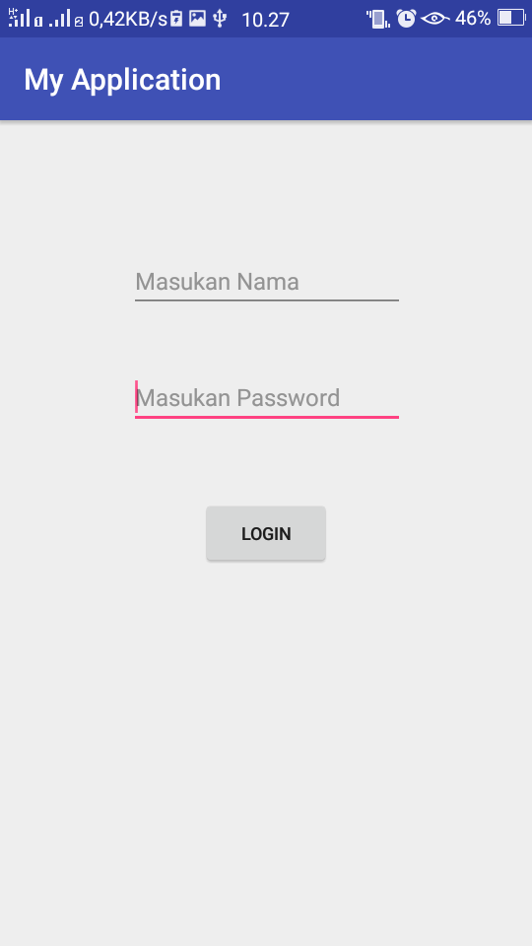

1. Membuat Activity Home

* Design activity home:

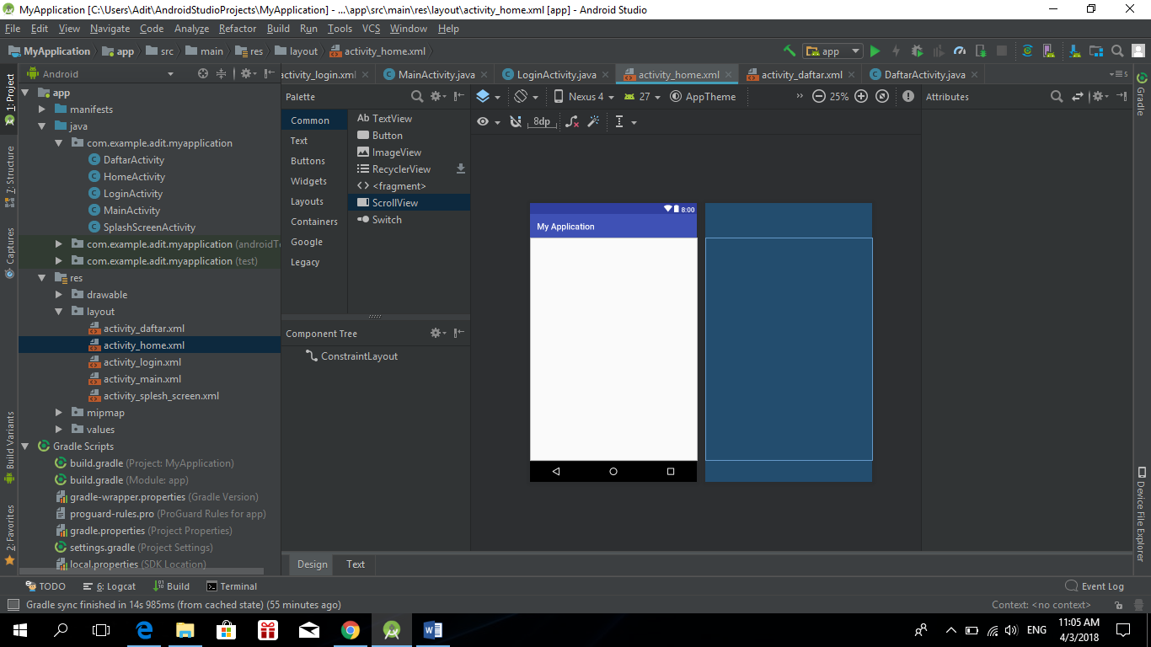

* Xml activity_home:

<?xml version="1.0" encoding="utf-8"?>  
<android.support.constraint.ConstraintLayout xmlns:android="http://schemas.android.com/apk/res/android"  
 xmlns:app="http://schemas.android.com/apk/res-auto"  
 xmlns:tools="http://schemas.android.com/tools"  
 android:layout_width="match_parent"  
 android:layout_height="match_parent"  
 tools:context=".HomeActivity">  
  
</android.support.constraint.ConstraintLayout>

* Coding HomeActivity:

package com.example.adit.myapplication;  
  
import android.content.Intent;  
import android.support.v7.app.AppCompatActivity;  
import android.os.Bundle;  
import android.view.View;  
import android.widget.Button;  
  
public class HomeActivity extends AppCompatActivity {  
  
 @Override  
 protected void onCreate(Bundle savedInstanceState) {  
 super.onCreate(savedInstanceState);  
 setContentView(R.layout.*activity_home*);  
 }  
}

* Output Activity Home:

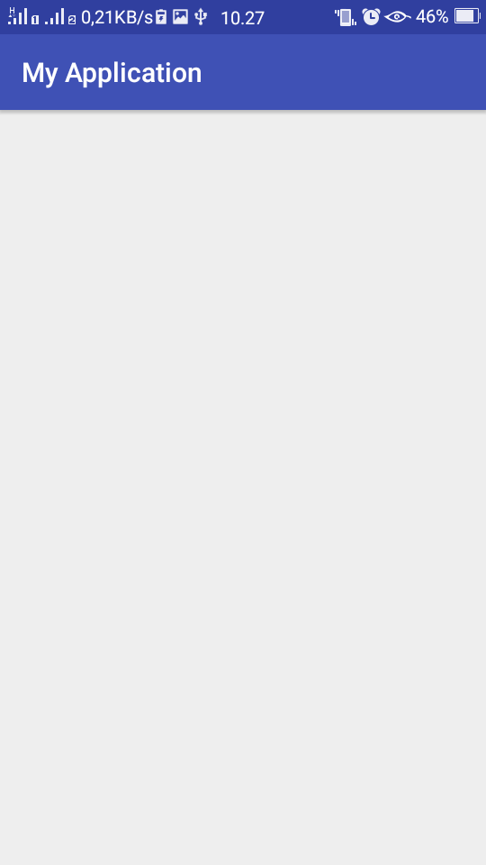

1. Membuat Share Preference

* Share preference pada aplikasi yang saya buat hanya pada login activity, yaitu ketika aplikasi tersebut di close maka pada activity login akan tetap ada username dan password pada saat kita login sebelumnya.
* Coding share preference:

package com.example.adit.myapplication;  
  
import android.content.Context;  
import android.content.Intent;  
import android.content.SharedPreferences;  
import android.support.v7.app.AppCompatActivity;  
import android.os.Bundle;  
import android.view.View;  
import android.widget.Button;  
import android.widget.EditText;  
  
public class LoginActivity extends AppCompatActivity {  
 public SharedPreferences coba;  
  
  
 @Override  
 protected void onCreate(Bundle savedInstanceState) {  
 super.onCreate(savedInstanceState);  
 setContentView(R.layout.*activity_login*);  
  
 final EditText editText4 = (EditText) findViewById(R.id.*editText4*);  
 final EditText editText5 = (EditText) findViewById(R.id.*editText5*);  
  
 Button button4 = (Button) findViewById(R.id.*button4*);  
  
 coba = getSharedPreferences("data", Context.*MODE_PRIVATE*);  
 editText4.setText(coba.getString("username", ""));  
 editText5.setText(coba.getString("password", ""));  
  
  
 button4.setOnClickListener(new View.OnClickListener() {  
 @Override  
 public void onClick(View view) {  
  
 SharedPreferences.Editor edit =coba.edit();  
 edit.putString("username", editText4.getText().toString());  
 edit.putString("password", editText5.getText().toString());  
 edit.apply();  
  
 Intent il = new Intent (getApplicationContext(),HomeActivity.class);  
 startActivity(il);  
 }  
 });  
 }  
}

* Output Share Preference:

